|  |  |  |  |  |
| --- | --- | --- | --- | --- |
|  |  | | |  |
|  |  | | |  |
|  | EM Registers  <<Feature>>  (F003951) | | |  |
|  |  | | |  |
| Document Type | **Feature Document (FD)** | | |  |
| Template Version | **6.0b / FFSD 8.0** | | |  |
| SysML Report Template Version | **O (11/12/2019)** | | |  |
| Document ID | **ffst01.10_featuredocument_sysmlreporttemplate** | | |  |
| Document Location |  | | |  |
| Document Owner | **Smith, George (G.) <gsmit560@ford.com>** | | |  |
| Document Revision | **FD0** | | |  |
| Document Status | **Draft** | | |  |
| Date Issued | **2021-02-24** | | |  |
| Date Revised | **2021-02-24** | | |  |
| Document Classification | GIS1 Item Number: | **27.60/35** | |  |
| GIS2 Classification: | **Confidential** | |
|  | | | | |
|  | | | | |
| Document Approval | | | | |
| Person | Role | | Email Confirmation | Date |
|  |  | |  |  |
|  |  | |  |  |

**Auto-Generated by MagicDraw**

Printed Copies Are Uncontrolled

# Disclaimer

**This document contains Ford Motor Company Confidential information. Disclosure of the information contained in any portion of this document is not permitted without the expressed, written consent of a duly authorized representative of Ford Motor Company, Dearborn, Michigan, U.S.A.**

**Copyright, Ó 2016 Ford Motor Company**

This document contains information developed and accumulated by and for FORD MOTOR COMPANY. As such, it is a proprietary document, which, if disseminated to unauthorized persons, would provide others with restricted information, data, or procedures not otherwise available, exposing the FORD MOTOR COMPANY to potential harm.

Employees and suppliers having custody of this specification or authorized to use it must be cognizant of its proprietary nature and ensure that the information herein is not made available to unauthorized persons.

FORD MOTOR COMPANY reserves the right to protect this work as an unpublished copyrighted work in the event of an inadvertent or deliberate unauthorized publication. FORD MOTOR COMPANY also reserves its rights under copyright laws to protect this work as a published work.

This document or portions thereof shall not be distributed outside FORD MOTOR COMPANY without prior written consent. Refer all questions concerning disclosure to the author(s) or to any duly authorized representative of Ford Motor Company.

# Contents

1.1.2 Decomposition of Functional Safety Requirement 13

Disclaimer 22

Contents 23

2 Introduction 26

2.1 Document Purpose 26

2.2 Document Scope 26

2.3 Document Audience 26

2.3.1 Stakeholder List 26

2.4 Document Organization 26

2.4.1 Document Context 26

2.4.2 Document Structure 27

2.5 Document Conventions 27

2.5.1 Requirements Templates 27

3 Feature Overview 28

3.1 Purpose and Description of Feature 28

3.2 Feature Variants 28

3.2.1 Regions & Markets 29

3.3 Input Requirements 29

3.3.1 Legal Requirements 30

3.3.2 Trustmark Requirements 30

3.3.3 Industry Standards 30

3.3.4 Attribute Requirements 30

3.4 Lessons Learned 30

3.5 Assumptions 31

3.6 References 31

3.6.1 Ford Documents 32

3.6.2 External Documents and Publications 32

3.7 Glossary 33

3.7.1 Parameters / Values 33

4 Feature Context 34

4.1 Feature Context Diagram 34

4.2 List of Influences 34

5 Feature Modeling 36

5.1 Operation Modes and States 36

5.2 Use Cases 38

5.2.1 Use Case Diagram 38

5.2.2 Actors 39

5.2.3 Use Case Descriptions 39

5.3 Driving and Operation Scenarios 43

5.4 Decision Tables 45

6 Feature Requirements 46

6.1 Functional Requirements 46

6.1.1 Error Handling 47

6.2 Non-Functional Requirements 47

6.2.1 Safety 47

6.2.2 Security 47

6.2.3 Reliability 47

6.3 HMI Requirements 47

6.4 Other Requirements 48

6.4.1 Design Requirements 48

6.4.2 Manufacturing Requirements 48

6.4.3 Service Requirements 48

6.4.4 After Sales Requirements 48

6.4.5 Process Requirements 48

6.4.6 Uncategorized Requirements 49

7 Functional Safety 50

7.1 System Behaviors for HARA 50

7.2 Safety Assumptions 50

7.3 Safety Goals 51

7.4 Functional Safety Requirements 53

7.4.1 Safety Goal: 53

7.4.2 Derivation of Functional Safety Requirements on Assumptions 55

7.5 ASIL Decomposition of Functional Safety Requirements 56

8 Architecture 57

8.1 Functional Architecture 57

8.1.1 List of Functions 57

8.2 Logical Architecture 58

8.2.1 Logical Interfaces 59

9 Open Concerns 61

10 Revision History 62

11 Appendix 63

11.1 Definitions 63

11.2 Abbreviations 63

**List of Figures**

Figure 1. 12

Figure 2: 28

Figure 3: - 28

Figure 4: 34

Figure 5: 36

Figure 6: 38

Figure 7:  55

Figure 8: 57

Figure 9: 58

**List of Tables**

Table 1: Features described in this FD 26

Table 2: Feature Variants 29

Table 3: Regions & Markets 29

Table 4: Ford internal Documents 32

Table 5: Ford internal Documents *(not specified in SysML model)* 32

Table 6: External documents and publications 32

Table 7: External documents and publications *(not specified in SysML model)* 33

Table 8: Parameters / Values used in this document *(Not supported by MagicDraw report generation)* 33

Table 9: List of Influences 35

Table 10: Operation Modes and States on 36

Table 11: Transitions between Operation Modes and States on 38

Table 12: List of Actors 39

Table 13: System Behaviors for HARA 50

Table 14: Functional Safety Assumptions 51

Table 15: Functional Safety Goals 53

Table 16: List of Functions 58

Table 17: List of Functions on 58

Table 18: Feature Interactions 59

Table 19: Feature Interactions on 59

Table 20: Open Concerns *(Not supported by MagicDraw report generation)* 61

Table 21: Definitions used in this document 63

Table 22: Abbreviations used in this document 64

# Introduction

## Document Purpose

A Feature Document (FD) document specifies **what** the feature shall do and how it shall behave from customer perspective. It should also provide reasoning and background **why** we have the feature in the vehicle.

The FD also serves as an Item Definition as defined by ISO26262 for those features, which follow the Ford Functional Safety process.

To get more information about the concept of feature, function and component level abstraction refer to the [Ford RE Wiki](http://wiki.ford.com/display/RequirementsEngineering/Requirements+Engineering+for+SW+Enabled+Features). For details on the Ford Functional Safety (ISO26262) process refer to the [Ford Functional Safety Sharepoint](https://pd3.spt.ford.com/sites/GlobalFunctionalSafety/Pages/default.aspx).

## Document Scope

This Feature Document (FD) specifies the following features:

|  |  |  |  |
| --- | --- | --- | --- |
| **Feature ID** | **Feature Name** | **Owner** | **Reference** |
| F003951 | EM Registers  (Program(s): CDX746/747 24MY) | Smith, George (G.) <gsmit560@ford.com> |  |

Table 1: Features described in this FD

## Document Audience

The FD is written by the feature owner of Smith, George (G.) <gsmit560@ford.com>. All Stakeholders, i.e., all people who have a valid interest in the feature should read and, if possible, review the FD. It needs to be guaranteed, that all stakeholders have access to the currently valid version of the FD.

**#Hint:** The FD template has the IP Classification “Proprietary” by default. IP Classification “Confidential” might be required in some cases, e.g. by Ford Functional Safety.

### Stakeholder List

For the latest list of stakeholder of the feature and their influence refer to <Put VSEM Link here>.

**#Hint:** Refer to [Ford RE Wiki – Stakeholder List](http://wiki.ford.com/display/RequirementsEngineering/Stakeholder+Analysis) on how to create a stakeholder list. The stakeholder list should be stored in VSEM in the pseudo folder “General Data Artifacts” of the corresponding feature.

## Document Organization

### Document Context

Refer to the [Specification Structure page](http://wiki.ford.com/display/RequirementsEngineering/Specification+templates) in the [Ford RE Wiki](http://wiki.ford.com/display/RequirementsEngineering/Requirements+Engineering+for+SW+Enabled+Features) to understand how the FD relates to other Ford Requirements Documents and Specifications.

### Document Structure

The structure of this document is explained below:

**Section 1** – Introduction how to use this document including responsibilities and requisite documents. Explains the terminology. Gives a clarification of the definitions, concepts and abbreviations used in the document.

**Section 2** – Feature Description. States briefly the background and the purpose of the feature, feature variants and corresponding regions and markets. Also includes input requirements, assumptions and constraints.

**Section 3** – Feature Context describes all external entities, which have an influence on the feature.

**Section 4** – Feature Modeling. Contains Use Case, Driving Scenarios, State Charts to describe the functional behavior of the feature.

**Section 5** – Safety. Lists System Behaviors and Safety Goals of the feature.

**Section 6** – Feature Requirements. Lists functional and non-functional requirements of the feature.

**Section 7** – Architecture. Shows the coarse architecture, which the feature requirements are deployed to. Describes the elements and the boundary of the feature as well as the decomposition and distribution of associated functions.

**Section 8** – List of Open Concerns

**Section 9** – Document Change History including a list of new or modified requirements. The requirements in this document are tagged, and this section contains different types of tables listing all, new, or changed requirements by their title and page no.

**Section 10** – Appendix

**#Hint:** All sections are mandatory, unless explicitly marked by the tag “#Classification” as “optional” or as applicable e.g. to certain domains like “Functional Safety”.

## Document Conventions

### Requirements Templates

Each requirement, use case or scenario in this specification shall follow the corresponding template given in the document template *Specification_Macros.dotm* at [RE Wiki - Specification Templates](http://wiki.ford.com/display/RequirementsEngineering/Specification+templates?src=contextnavpagetreemode).

#### Identification of requirements

#### Requirements Attributes

The templates provided by *Specification_Macros.dotm* define a list of attributes for each requirement. This helps to classify the requirement. The attributes are explained at [RE Wiki - Requirements Attributes](http://wiki.ford.com/display/RequirementsEngineering/Requirements+Attributes?src=contextnavpagetreemode).

## References

### Ford Documents

List here all Ford internal documents, which are directly related to the feature.

| **Reference** | **Title** | **Doc. ID** | **Document Location** | **Revision** |
| --- | --- | --- | --- | --- |
| Ford GIS Standard | Ford GIS Standard |  |  |  |

Table 4: Ford internal Documents

### External Documents and Publications

The list of external documents could include books, reports and online sources.

**#Hint:** You may refer to [IEEE Citation Reference](http://www.ieee.org/documents/ieeecitationref.pdf) on how to format a reference.

| **Reference** | **Document / Publication** | **Document Location** |
| --- | --- | --- |
| IEEE Std 1012-2004 IEEE Standard for Software Verification and Validation |  |  |
| ISO/IEC 19500-2:2003 | Information technology -- Open Distributed Processing -- Part 2 |  |
| UML Testing Profile (UTP), v1.2 |  |  |
| Wikipedia |  |  |

Table 6: External documents and publications

## Glossary

**#Hint**: Terms, concepts and abbreviations used in the document shall be defined and illustrated here. Note that changes to terms and/or concepts described in this section tend to cause major updates to this document.

The tables below have feature specific definitions and abbreviations. For additional, non-feature specific terms please refer to the [RE Glossary](http://wiki.ford.com/display/RequirementsEngineering/Glossary?src=contextnavpagetreemode)

See Appendix for Definitions and Abbreviations.

### Parameters / Values

| **Name** | **Description** | **Range / Resolution** |
| --- | --- | --- |
|  |  |  |

Table 8: Parameters / Values used in this document *(Not supported by MagicDraw report generation)*

# Feature Overview

## Purpose and Description of Feature

**#Hint:** Some descriptive text to explain the purpose and functionality of the feature.

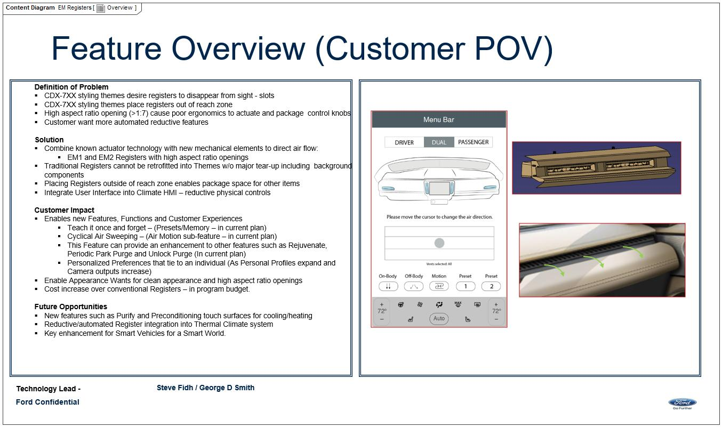

Figure 2: Overview

## Feature Variants

**#Hint:** Definitions for different variants of the feature (if applicable). Give each variant a descriptive name by which it can be referenced further on in the document. If no variant exists, state “No Feature Variants”.

The Variant Description should give a short informative text which describes the variants of the feature.

|  |  |  |
| --- | --- | --- |
| **Variant Name** | **Variant Description** | **Remarks** |
| **FNA** | Variant for FNA |  |

Table 2: Feature Variants

### Regions & Markets

**#Hint:** Description of purpose and functionality of the feature. If there is no variant, give feature name in first column.

|  |  |  |  |  |  |  |
| --- | --- | --- | --- | --- | --- | --- |
| **Market /**  **Region**  Variant Name | **North America** | **South America** | **Europe** | **Middle East/Africa** | **Asia / Pacific** | **China** |
| **FNA** | Mandatory | No | Mandatory | No | No | Mandatory |

Table 3: Regions & Markets

## Input Requirements

**#Hint:** List all input requirements, which are relevant for the feature. Typically, attribute requirements, legal requirements as well as national and international standards have to be considered.

### Legal Requirements

* : Compliance with FMVSS101
  + The Feature shall comply with FMVSS101.

### Trustmark Requirements

* : Air Register Applied Loads from IP-0117
  + Register shall withstand loads of 100N and remain functional.
* : Air Register Life Cycle from IP-0114
  + Registers shall withstand at least 7000 cycles.

### Industry Standards

* : ISO 26262
  + The system shall be developed according to Ford's implementation of Functional Safety.

### Attribute Requirements

* : Electrically Actuated
  + EM Registers has electrically actuated and not human actuated air vents.
* : Fast and Accurate
  + EM Registers shall provide fast and accurate control of the air vents.
* : HMI Feedback
  + EM Registers shall give visual feedback to the User through the HMI.
* : HVAC Vent Air Flow Direction Interface
  + EM Registers shall control the direction of air exiting the Registers by interfacing with the HMI.
* : Personalizable
  + EM Registers shall be personalizable. (PPP and/or Preset)
* : Registers remember users last chosen position Memory
  + EM Registers shall remember Users last chosen registers directions.

## Lessons Learned

**#Hint:** Additional information and lessons learned from previous development or related features. A typical source for Lessons Learned is the FMA Quality History.

**#Functional Safety:** In context of Functional Safety Lessons Learned and similar information will be used to check the completeness of the Functional Safety Goals and assumptions in the Hazard Analysis and Risk Assessment (HARA).

**#Link:** [Ford Functional Safety Sharepoint](https://pd3.spt.ford.com/sites/GlobalFunctionalSafety/Pages/default.aspx)

No lessons learned specified.

## Assumptions

**#Classification**: Optional

**#Hint:** A list of known assumptions concerning the effects of the feature’s behavior on other features or elements (i.e., dependencies) as well as assumptions on the behavior expected by the feature (e.g. known limitations). During the course of the feature development most of those assumptions are typically either converted into actual requirements or discarded at some point – such that this chapter remains mostly empty. For assumptions, which are relevant for the Functional Safety process refer to chapter 7.2 “Safety Assumptions”

No Assumptions specified.

# Feature Context

## Feature Context Diagram

**#Hint:** High level diagram of feature interactions with the environment, people or other feature or other external entities.

**#Link:** [RE Wiki - Context Diagram](http://wiki.ford.com/pages/viewpage.action?pageId=107676234&src=contextnavpagetreemode)

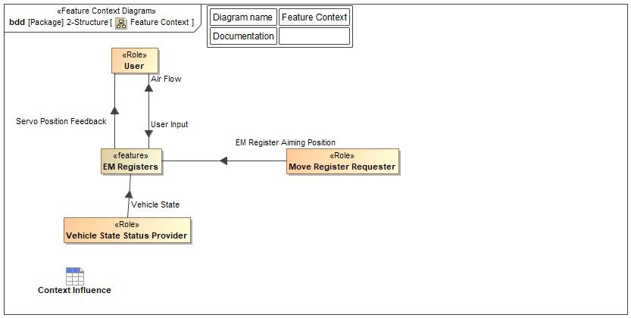

Figure 4: Feature Context

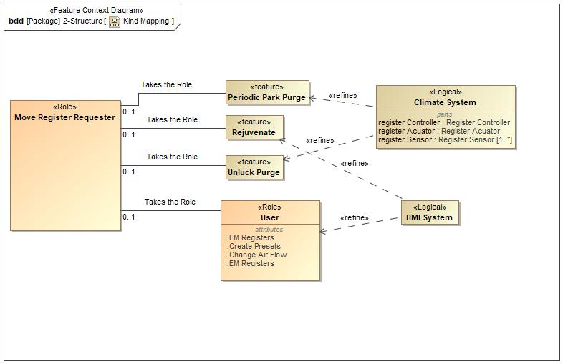

Figure 4: Kind Mapping

## List of Influences

|  |  |  |
| --- | --- | --- |
| **ID** | **External Entity** | **Influence Description** |
| Air Flow | EM Registers To User | Physical air flow to the user/cabin from the feature |
| EM Register Aiming Position | Move Register Requester To EM Registers | Features(such as Rejuvenate) give commands to EM Register Feature on Air Flow, Position, and Movement |
| Servo Position Feedback | EM Registers To User | Feature gives feedback to the User of the servo/louver position and movement |
| User Input | User To EM Registers | User inputs desired position and movement for registers. |
| Vehicle State | Vehicle State Status Provider To EM Registers | Gives the Vehicle state of the vehicle to trigger the start up and shut down attributes of the feature. |

Table 9: List of Influences

# Feature Modeling

## Operation Modes and States

**#Classification:** Optional (Mandatory for Functional Safety)

**#Link:** [RE Wiki – State Charts](http://wiki.ford.com/display/RequirementsEngineering/State+Charts?src=contextnavpagetreemode)

**#Hint:** State Charts are a popular means to express feature behavior in terms of states and modes. An advantage of this state machine like approach is that consistency can be easily verified.

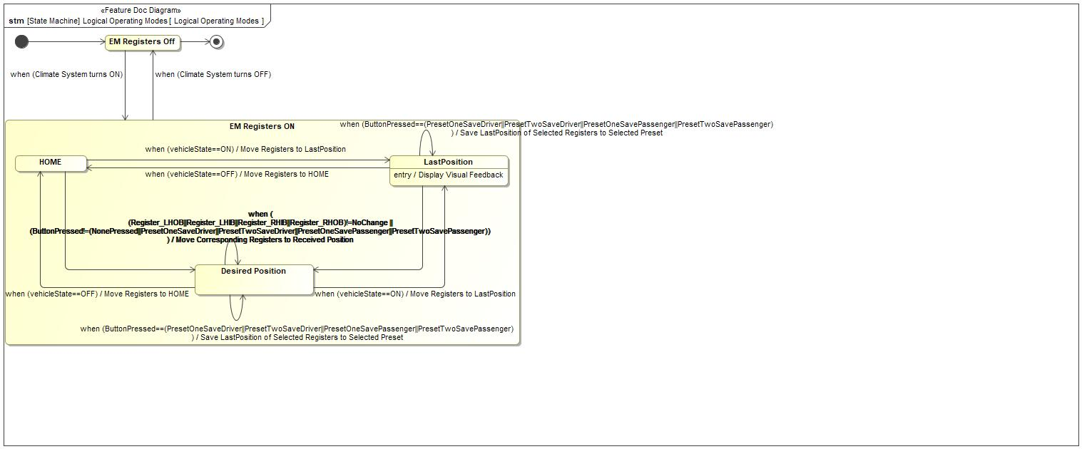

Figure 5: Logical Operating Modes

|  |  |  |
| --- | --- | --- |
| **State** | **Description** | **Requirements Reference** (optional) |
| Desired Position | Registers moved to desired position state |  |
| EM Registers Off | EM Registers Off State |  |
| EM Registers ON | EM Registers on state |  |
| HOME | Register HOME position state when registers move to a standard nominal position |  |
| LastPosition | Entry behavior: Display Visual Feedback |  |

Table 10: Operation Modes and States on Logical Operating Modes

|  |  |  |
| --- | --- | --- |
| **Transition ID** | **Description** | **Requirements Reference**  (optional) |
| T1 |  |  |
| T2 |  |  |
| T3 | Name: Move Registersto HOME position  Effect: Move Corresponding Registers to Received Position |  |
| T4 | Effect: Move Corresponding Registers to Received Position |  |
| T5 | Effect: Move Registers to LastPosition |  |
| T6 |  |  |
| T7 | Name: Move Registers to Desired Position  Effect: Move Corresponding Registers to Received Position |  |
| T8 | Effect: Move Registers to HOME |  |
| T9 |  |  |
| T10 | Name: when (ButtonPressed==(PresetOneSaveDriver||PresetTwoSaveDriver||PresetOneSavePassenger||PresetTwoSavePassenger))  / Save LastPosition of Selected Registers to Selected Preset |  |
| T11 | Name: when (ButtonPressed==(PresetOneSaveDriver||PresetTwoSaveDriver||PresetOneSavePassenger||PresetTwoSavePassenger))  / Save LastPosition of Selected Registers to Selected Preset |  |
| T12 |  |  |
| T13 | Name: after (30 seconds) && when(vehicleState==OFF) |  |

Table 11: Transitions between Operation Modes and States on Logical Operating Modes

## Use Cases

**#Classification:** Optional

**#Link:** [RE Wiki – Use Cases](http://wiki.ford.com/display/RequirementsEngineering/Use+Cases+Overview?src=contextnavpagetreemodehttp://wiki.ford.com/display/RequirementsEngineering/Use+Cases?src=contextnavpagetreemode)

### Use Case Diagram

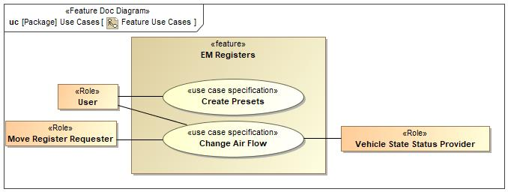

Figure 6: Feature Use Cases

### Actors

| **Actor** | **Description** |
| --- | --- |
| Move Register Requester | This Block is taking the place of every Feature that will be interacting with the EM Registers Feature for the purposes of moving the registers. The Kind Mapping will show what features this block is representing. |
| User | The User is anyone that is inside the vehicle. |
| Vehicle State Status Provider | The EM Registers feature needs to know when the vehicle is turned on(AKA the ignition is turned over). |

Table 12: List of Actors

### Use Case Descriptions

**#Classification:** Optional

Change Air Flow

|  |  |  |
| --- | --- | --- |
| **Actors** | Primary | Move Register Requester |
| Secondary | Vehicle State Status Provider |
|  | User |
| **Subject** |  | EM Registers |
| **Description** |  |  |
| **Preconditions** |  |  |
| **Triggers** | T1 | Move Register Requestor Send Register Move Request From Another Feature |
| T2 | User Request to Adjust Register |
| T3 | User Selects Cycling Option |
| T4 | User Selects Preset |
| T5 | Move Register Requestor Turns Vehicle ON/OFF |
| **Main Flow Description** |  | The Registers are moved as desired. |
| **Main Flow** | M1 | EM Registers Move Registers |
| M2 | User Receives Feeback . |
| **Exceptional Flow Description** |  | EM Registers feature behavior when vehicle is Turned ON/OFF |
| **Exceptional Flow Steps** | E1 | Move Register Requestor Turns Vehicle ON/OFF. |
| E2 | EM Registers Move Registers |
| **Postconditions** | PostC1 | Registers have moved resulting in changed air flow within the cabin. |

Create Presets

|  |  |  |
| --- | --- | --- |
| **Actors** | Primary | User |
| **Subject** |  | EM Registers |
| **Description** |  |  |
| **Preconditions** | PreC1 | HMI is ON. |
| PreC2 | User has selected desired registers to store into preset. |
| PreC3 | Vehicle is ON. |
| **Triggers** | T1 | User Presses and Holds Preset Button |
| **Main Flow Description** |  | A Preset is programed/saved. |
| **Main Flow** | M1 | User presses and holds the desired preset button |
| M2 | EM Registers Saves LastPosition in Preset |
| **Postconditions** | PostC1 | Register positions are saved into selected Preset. |

## Driving and Operation Scenarios

**#Classification:** Optional (Mandatory for Functional Safety)

**#Functional Safety:** Driving and operating scenarios which impact the functionality of the feature can be used to check, if the situation analysis in the HARA is complete

**#Link:** [RE Wiki – Driving Scenarios](http://wiki.ford.com/display/RequirementsEngineering/Driving+Scenarios?src=contextnavpagetreemode)

## Decision Tables

**#Classification:** Optional

**#Link:** [RE Wiki – Decision Tables](http://wiki.ford.com/display/RequirementsEngineering/Decision+Table).

**#Hint:** Use decision table, if behavior is not state based (in that case prefer state chart from ch. 5.1) and based purely on current inputs.

*Not supported by MagicDraw report generation.*

# Feature Requirements

**#Functional Safety:** In general, safety requirements are not listed here. However, it is possible that later in the development process, a non-safety requirement becomes a safety requirement. In such a case it may remain on this list.

**#Link:** [RE Wiki – How to write good requirements](http://wiki.ford.com/display/RequirementsEngineering/How+to+write+better+requirements?src=contextnavpagetreemode).

## Functional Requirements

EM Reg Cyclical Move Command

When Cyclical movement request is received, EM Registers shall request relevant registers to move in the pre-defined cyclical pattern.

|  |  |  |  |  |  |  |  |
| --- | --- | --- | --- | --- | --- | --- | --- |
| Requirement ID: | | | | | | | |
| **Rationale** | Provide user with specific pattern of air flow for a better user experience. | | | | | | |
| **Acceptance Criteria** | Oberservation of air motions. | | | | | | |
| **Notes** |  | | | | | | |
| **Source** |  | | | | | **Owner** |  |
| **Source Req.** | * 1901375047.jpg HVAC Vent Air Flow Direction Interface | | | | | **V&V Method** |  |
| **Type** |  | | | **Priority** |  | **Status** | In-Progress |
| [Req. Template](http://wiki.ford.com/display/RequirementsEngineering/Requirements+Attributes) Version | | 6.0 | End of Requirement | | | | |

EM Reg Preset Aim Memo

The EM Register feature shall provide the capability of memorizing preset positions when chosen.

|  |  |  |  |  |  |  |  |
| --- | --- | --- | --- | --- | --- | --- | --- |
| Requirement ID: | | | | | | | |
| **Rationale** | Provide a better user experience by memorizing user settings. | | | | | | |
| **Acceptance Criteria** | Oberservation that settings were memorized | | | | | | |
| **Notes** |  | | | | | | |
| **Source** |  | | | | | **Owner** |  |
| **Source Req.** | * 1901375047.jpg Personalizable | | | | | **V&V Method** |  |
| **Type** |  | | | **Priority** |  | **Status** | In-Progress |
| [Req. Template](http://wiki.ford.com/display/RequirementsEngineering/Requirements+Attributes) Version | | 6.0 | End of Requirement | | | | |

EM Reg Move Command

When position request is received, EM Registers shall command registers to move to the desired position.

|  |  |  |  |  |  |  |  |
| --- | --- | --- | --- | --- | --- | --- | --- |
| Requirement ID: | | | | | | | |
| **Rationale** | Moves the Registers | | | | | | |
| **Acceptance Criteria** | Observation of air flow from registers. | | | | | | |
| **Notes** |  | | | | | | |
| **Source** |  | | | | | **Owner** |  |
| **Source Req.** | * 1901375047.jpg HVAC Vent Air Flow Direction Interface | | | | | **V&V Method** |  |
| **Type** |  | | | **Priority** |  | **Status** | In-Progress |
| [Req. Template](http://wiki.ford.com/display/RequirementsEngineering/Requirements+Attributes) Version | | 6.0 | End of Requirement | | | | |

EM Reg Memo Closed Pos

EM Registers shall automatically memorize the old Register position each time the Louvers change to the closed position.

|  |  |  |  |  |  |  |  |
| --- | --- | --- | --- | --- | --- | --- | --- |
| Requirement ID: | | | | | | | |
| **Rationale** | Allows the sytem to return the Registers to the last Aim Targets | | | | | | |
| **Acceptance Criteria** | Obseravation that Registrs moved to previous location. | | | | | | |
| **Notes** |  | | | | | | |
| **Source** |  | | | | | **Owner** |  |
| **Source Req.** | * 1901375047.jpg Registers remember users last chosen position Memory | | | | | **V&V Method** |  |
| **Type** |  | | | **Priority** |  | **Status** | In-Progress |
| [Req. Template](http://wiki.ford.com/display/RequirementsEngineering/Requirements+Attributes) Version | | 6.0 | End of Requirement | | | | |

EM Reg Memo Postion

EM Registers shall automatically memorize the new Register position each time the Louvers change position greater than Threshold.

|  |  |  |  |  |  |  |  |
| --- | --- | --- | --- | --- | --- | --- | --- |
| Requirement ID: | | | | | | | |
| **Rationale** | Allows the sytem to return the Registers to the last Aim Targets | | | | | | |
| **Acceptance Criteria** | Obseravation that Registrs moved to previous location. | | | | | | |
| **Notes** |  | | | | | | |
| **Source** |  | | | | | **Owner** |  |
| **Source Req.** | * 1901375047.jpg Registers remember users last chosen position Memory | | | | | **V&V Method** |  |
| **Type** |  | | | **Priority** |  | **Status** | In-Progress |
| [Req. Template](http://wiki.ford.com/display/RequirementsEngineering/Requirements+Attributes) Version | | 6.0 | End of Requirement | | | | |

EM Reg Home Position

EM Registers shall move the registers to the HOME position when the vehicle is turned OFF.

|  |  |  |  |  |  |  |  |
| --- | --- | --- | --- | --- | --- | --- | --- |
| Requirement ID: | | | | | | | |
| **Rationale** | Provide the user with continuity between vehicle on/off cycles. | | | | | | |
| **Acceptance Criteria** | Obervation that the EM Registers are the same after a vehicle on/off cycle. | | | | | | |
| **Notes** |  | | | | | | |
| **Source** |  | | | | | **Owner** |  |
| **Source Req.** | * 1901375047.jpg HVAC Vent Air Flow Direction Interface | | | | | **V&V Method** |  |
| **Type** |  | | | **Priority** |  | **Status** | In-Progress |
| [Req. Template](http://wiki.ford.com/display/RequirementsEngineering/Requirements+Attributes) Version | | 6.0 | End of Requirement | | | | |

EM Reg Preset Command

EM Registers shall move registers to Preset memorized locations when selected by User through HMI.

|  |  |  |  |  |  |  |  |
| --- | --- | --- | --- | --- | --- | --- | --- |
| Requirement ID: | | | | | | | |
| **Rationale** | Provide user with easy preset buttons. | | | | | | |
| **Acceptance Criteria** | Observation of air flow from registers. | | | | | | |
| **Notes** |  | | | | | | |
| **Source** |  | | | | | **Owner** |  |
| **Source Req.** | * 1901375047.jpg Personalizable * 1901375047.jpg HVAC Vent Air Flow Direction Interface | | | | | **V&V Method** |  |
| **Type** |  | | | **Priority** |  | **Status** | In-Progress |
| [Req. Template](http://wiki.ford.com/display/RequirementsEngineering/Requirements+Attributes) Version | | 6.0 | End of Requirement | | | | |

EM Reg Vehicle ON

The EM Register feature shall move the registers to the LastPosition position when the ignition is turned ON.

|  |  |  |  |  |  |  |  |
| --- | --- | --- | --- | --- | --- | --- | --- |
| Requirement ID: | | | | | | | |
| **Rationale** | Provide the user with continuity between vehicle on/off cycles. | | | | | | |
| **Acceptance Criteria** | Obervation that the EM Registers are the same after a vehicle on/off cycle. | | | | | | |
| **Notes** |  | | | | | | |
| **Source** |  | | | | | **Owner** |  |
| **Source Req.** | * 1901375047.jpg Registers remember users last chosen position Memory * 1901375047.jpg HVAC Vent Air Flow Direction Interface | | | | | **V&V Method** |  |
| **Type** |  | | | **Priority** |  | **Status** | In-Progress |
| [Req. Template](http://wiki.ford.com/display/RequirementsEngineering/Requirements+Attributes) Version | | 6.0 | End of Requirement | | | | |

### Error Handling

No Error Handling Requirements specified.

## Non-Functional Requirements

***#Hint:*** *Non-functional requirements specify some performance criteria in addition to the functional behavior given defined by the functional requirements. Timing (if not already included in the functional requirements), security details (e.g. how secure does an algorithm have to be) reliability (e.g. mean time between failure) or maintainability could be specified in this section.*

### Safety

**#Hint:** Only those safety requirements, which are not related to Functional Safety (ISO26262) should go here. For Functional Safety refer to chapter 7 “Functional Safety”.

*Not supported by MagicDraw report generation.*

### Security

No Security Requirements specified.

### Reliability

No Reliability Requirements specified.

## HMI Requirements

**#Hint:** Requirements in this section could specify details of e.g. the icons, the GUI or the sounds.

EM Reg HMI Functionality

The EM Register feature shall provide means to control register position and cyclical settings through HMI.

|  |  |  |  |  |  |  |  |
| --- | --- | --- | --- | --- | --- | --- | --- |
| Requirement ID: | | | | | | | |
| **Rationale** | Provide the user with the ability to manually aim registers. | | | | | | |
| **Acceptance Criteria** | Obeservation of air flow. | | | | | | |
| **Notes** |  | | | | | | |
| **Source** |  | | | | | **Owner** |  |
| **Source Req.** | * 1901375047.jpg HVAC Vent Air Flow Direction Interface | | | | | **V&V Method** |  |
| **Type** |  | | | **Priority** |  | **Status** | In-Progress |
| [Req. Template](http://wiki.ford.com/display/RequirementsEngineering/Requirements+Attributes) Version | | 6.0 | End of Requirement | | | | |

EM Reg HMI Feedback

The EM Register feature shall provide visual feedback of Register Aim directions, Register Air Motion, Register shut off.

|  |  |  |  |  |  |  |  |
| --- | --- | --- | --- | --- | --- | --- | --- |
| Requirement ID: | | | | | | | |
| **Rationale** | Provide the user with visual feedback of the air flow. | | | | | | |
| **Acceptance Criteria** | Obersvation of visual feedback. | | | | | | |
| **Notes** |  | | | | | | |
| **Source** |  | | | | | **Owner** |  |
| **Source Req.** | * 1901375047.jpg HMI Feedback | | | | | **V&V Method** |  |
| **Type** |  | | | **Priority** |  | **Status** | In-Progress |
| [Req. Template](http://wiki.ford.com/display/RequirementsEngineering/Requirements+Attributes) Version | | 6.0 | End of Requirement | | | | |

## Other Requirements

### Design Requirements

***#Hint:*** *Requirements of a Logical Function should be typically agnostic of their SW/HW implementation*. If for specific reasons the function owner needs to define explicitly design constraints on the solution, it can be done in this chapter.

*Not supported by MagicDraw report generation.*

### Manufacturing Requirements

No Manufacturing Requirements specified.

### Service Requirements

**#Hint:** Requirements in this section could specify, e.g. what needs to be considered, if individual ECUs are replaced or new SW is flashed to ECUs (parameter set in non-volatile memory might get inconsistent and needs also to be updated).

No Service Requirements specified.

### After Sales Requirements

**#Hint:** Requirements in this section could specify, e.g. input for the Owner’s Manual could be gathered.

No After Sales Requirements specified.

### Process Requirements

**#Hint**: Requirements in this section are relevant for the development process of the feature, e.g. ISO26262 compliance.

No Process Requirements specified.

### Uncategorized Requirements

***#Hint:*** *Requirements* in this section are in scope of this Feature Document but do not fit in any of the previous categories.

Response Time

Registers shall have a response time of < 150ms.

|  |  |  |  |  |  |  |  |
| --- | --- | --- | --- | --- | --- | --- | --- |
| Requirement ID: | | | | | | | |
| **Rationale** | Provides a fast user experience. | | | | | | |
| **Acceptance Criteria** | Testing to oconfirm response time is < 150ms. | | | | | | |
| **Notes** |  | | | | | | |
| **Source** |  | | | | | **Owner** |  |
| **Source Req.** | * 1901375047.jpg Fast and Accurate | | | | | **V&V Method** |  |
| **Type** |  | | | **Priority** |  | **Status** | In-Progress |
| [Req. Template](http://wiki.ford.com/display/RequirementsEngineering/Requirements+Attributes) Version | | 6.0 | End of Requirement | | | | |

EM Reg After Calibration

EM Register feature shall move Registers to LastPosition after Calibration.

|  |  |  |  |  |  |  |  |
| --- | --- | --- | --- | --- | --- | --- | --- |
| Requirement ID: | | | | | | | |
| **Rationale** | Provides better User Experience | | | | | | |
| **Acceptance Criteria** | Oberservance | | | | | | |
| **Notes** | Non Functional Requirement | | | | | | |
| **Source** |  | | | | | **Owner** |  |
| **Source Req.** | * 1901375047.jpg Registers remember users last chosen position Memory | | | | | **V&V Method** |  |
| **Type** |  | | | **Priority** |  | **Status** | In-Progress |
| [Req. Template](http://wiki.ford.com/display/RequirementsEngineering/Requirements+Attributes) Version | | 6.0 | End of Requirement | | | | |

EM Reg Calibration

EM Registers shall calibrate the Registers after every stop/start Ignition Interval.

|  |  |  |  |  |  |  |  |
| --- | --- | --- | --- | --- | --- | --- | --- |
| Requirement ID: | | | | | | | |
| **Rationale** | Provide user with consistant lifelong accuracy of airflow direction. | | | | | | |
| **Acceptance Criteria** |  | | | | | | |
| **Notes** | Non Functional Requirement | | | | | | |
| **Source** |  | | | | | **Owner** |  |
| **Source Req.** | * 1901375047.jpg Fast and Accurate | | | | | **V&V Method** |  |
| **Type** |  | | | **Priority** |  | **Status** | In-Progress |
| [Req. Template](http://wiki.ford.com/display/RequirementsEngineering/Requirements+Attributes) Version | | 6.0 | End of Requirement | | | | |

Degrees per second

Registers shall move an average speed of 90 degrees per second within +/- 10 degrees per second.

|  |  |  |  |  |  |  |  |
| --- | --- | --- | --- | --- | --- | --- | --- |
| Requirement ID: | | | | | | | |
| **Rationale** | Provide consistent speed | | | | | | |
| **Acceptance Criteria** | Oberservance of consistent speed | | | | | | |
| **Notes** |  | | | | | | |
| **Source** |  | | | | | **Owner** |  |
| **Source Req.** | * 1901375047.jpg Fast and Accurate | | | | | **V&V Method** |  |
| **Type** |  | | | **Priority** |  | **Status** | In-Progress |
| [Req. Template](http://wiki.ford.com/display/RequirementsEngineering/Requirements+Attributes) Version | | 6.0 | End of Requirement | | | | |

EM Reg Position Location

EM Registers shall provide control accuracy of EM Register with position error less than MaxPositionError.

|  |  |  |  |  |  |  |  |
| --- | --- | --- | --- | --- | --- | --- | --- |
| Requirement ID: | | | | | | | |
| **Rationale** | Provides accurate control of Air Flow. | | | | | | |
| **Acceptance Criteria** | Observation that visual feedback matches air flow direction. | | | | | | |
| **Notes** |  | | | | | | |
| **Source** |  | | | | | **Owner** |  |
| **Source Req.** | * 1901375047.jpg Fast and Accurate | | | | | **V&V Method** |  |
| **Type** |  | | | **Priority** |  | **Status** | In-Progress |
| [Req. Template](http://wiki.ford.com/display/RequirementsEngineering/Requirements+Attributes) Version | | 6.0 | End of Requirement | | | | |

# Functional Safety

**#Classification**: Functional Safety only

**#Hint:** This section is dedicated to the Ford Functional Safety (ISO26262) process. For details of this process refer **#Link:** [Ford Functional Safety Sharepoint](https://pd3.spt.ford.com/sites/GlobalFunctionalSafety/Pages/default.aspx)

**#Contact:** [*RE Wiki Roles & Responsibilites page – Role: Application Functional Safety Engineer*](http://wiki.ford.com/display/RequirementsEngineering/Default+Contacts+for+Stakeholder+Roles#ApplicationFunctionalSafetyEngineer)

## System Behaviors for HARA

**#Classification**: Functional Safety only

**#Hint:** List of selected system behaviors is an input to the Hazard Analysis and Risk Assessment (HARA). There needs to be a rationale why other system behaviors / functions are not considered.

|  |  |
| --- | --- |
| **ID** | **Name** |
|  | Provide Continous Motion of Air Flow in Predetermined Patterns |
|  | Aim Air Flow Up/Dn/L/R as requested |
|  | Shut-off Air Flow from one or more vents |
|  | Aim Air flow to Predetermined Positions |
|  | Memorize Aiming Positon Set by Occupant |

Table 13: System Behaviors for HARA

## Safety Assumptions

**#Hint:** Copy the assumptions from the document "FFSD 02 Hazard Analysis and Risk Assessment”, Tab. “2 - Assumptions” with “Ref/ID”, “Name”, “Category”, “Description”, “Purpose”. In this document, additionally a reference to the requirement ID is inserted.

**#Link:** [Functional Safety Sharepoint](https://pd3.spt.ford.com/sites/GlobalFunctionalSafety/Pages/default.aspx) – HARA

No Safety Assumptions specified

## Safety Goals

**#Classification**: Functional Safety only

**#Hint:** The list of Functional Safety Goals is an output of the Hazard Analysis and Risk Assessment (HARA) and therefore not required during the initial creation of the Feature Document.

**#Link:** [Functional Safety Sharepoint](https://pd3.spt.ford.com/sites/GlobalFunctionalSafety/Pages/default.aspx) – HARA

|  |  |  |  |  |
| --- | --- | --- | --- | --- |
| ID | Goal | | | |
|  | **Goal Name** | Prevent Hazard (Example) | | |
| **Description** |  | | |
| **Safety Goal Concept** | Safety Goal Concept:  Warning & Recovery Concept: | | |
| **ASIL** |  | **FTTI** |  |
| **Related FSR IDs** |  | | |

Table 15: Functional Safety Goals

## Functional Safety Requirements

**#Classification**: Functional Safety only

**#Hint:** The section lists the Functional Safety Requirements (FSRs) derived from

* a Safety Goal (list in subsections 6.4.1 and following)

in this case each FSR should trace back to a safety goal in ch. 6.3

* and Assumptions (list in subsection 6.4.2).

in this case each FSR should trace back to an assumption in ch. 6.2.

In section 6.5 “ASIL Decomposition of Functional Safety Requirements” the initial FSRs from chapters 6.4.1 to 6.4.2 may be decomposed, if required.

**#Link:** [Functional Safety Sharepoint](https://pd3.spt.ford.com/sites/GlobalFunctionalSafety/Pages/default.aspx) – Functional Safety Concept

[RE Wiki - Requirements Attributes](http://wiki.ford.com/display/RequirementsEngineering/Requirements+Attributes)

**#Classification**: Functional Safety only

**#Hint:** The section lists the Functional Safety Requirements (FSRs) derived from a Safety Goal and Assumptions.

The following should be noted for the use of the attribute fields for FSRs

- The “Source Req” trace link field in each FSR should have a reference to

- a safety goal in ch. 6.3 “Safety Goals” or

- an assumption in ch. 6.2 “Safety Assumptions”

**#Link:** [Functional Safety Sharepoint](https://pd3.spt.ford.com/sites/GlobalFunctionalSafety/Pages/default.aspx) – Functional Safety Concept

[RE Wiki - Requirements Attributes](http://wiki.ford.com/display/RequirementsEngineering/Requirements+Attributes)

### Safety Goal: Prevent Hazard (Example)

**Name:** Prevent Hazard (Example)

**Purpose:**

**Text:**

**ASIL:**

#### Safety Goal Concept

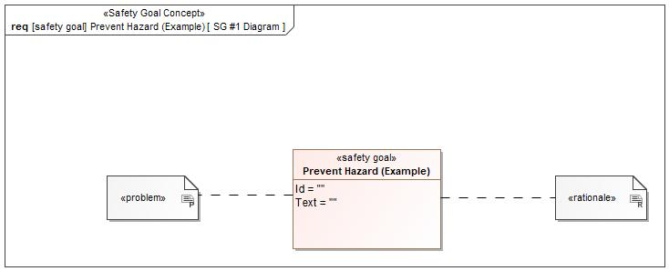

Figure 1: SG #1 Diagram – Prevent Hazard (Example)

*Note: The authoritative source for the Safety Goals is document “FFSD 02 Hazard Analysis* *and Risk Assessment”. The documentation of Safety Goals in this chapter (In the Argumentation for Safety Goal achievement) is for information purposes only.*

*The authoritative source for the Functional Safety Requirements is section 2.1.x.3: of this document. The documentation of Functional Safety Requirements in the following chapter (complete or summarised) is for information purposes only.*

#### Warning and Recovery Concept

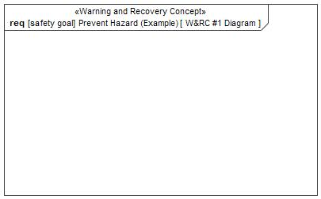

Figure 7: W&RC #1 Diagram – Prevent Hazard (Example)

#### FSRs for - Prevent Hazard (Example)

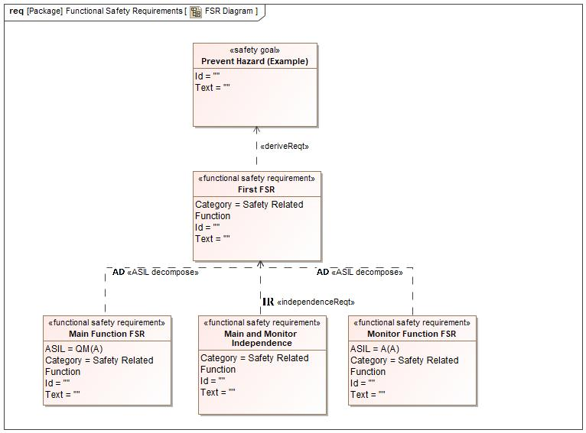

Figure 1. Prevent Hazard (Example)

Monitor Function FSR

Related to:

* Safe States:
  + Safe State #1

|  |  |  |  |  |  |  |  |
| --- | --- | --- | --- | --- | --- | --- | --- |
| Requirement ID: | | | | | | | |
| **Purpose** |  | | | | | | |
| **V&V Acceptance Criteria** |  | | | | | | |
| **Notes** |  | | | | | | |
| **Source** |  | | | | | **Owner** |  |
| **Source Req.** | * 1721163356.jpg Prevent Hazard (Example) | | | | | **V&V Method** |  |
| **Type** | N/A | | **Priority** | | N/A | **Status** |  |
| **ASIL** | A(A) | | **Category** | | Safety Related Function | **Fault Handling Time** | N/A |
| [Req. Template](http://wiki.ford.com/display/RequirementsEngineering/Requirements+Attributes) Version | | 6.0 | | End of Requirement | | | |

Main Function FSR

Related to:

* Safe States:
  + Safe State #1

|  |  |  |  |  |  |  |  |
| --- | --- | --- | --- | --- | --- | --- | --- |
| Requirement ID: | | | | | | | |
| **Purpose** |  | | | | | | |
| **V&V Acceptance Criteria** |  | | | | | | |
| **Notes** |  | | | | | | |
| **Source** |  | | | | | **Owner** |  |
| **Source Req.** | * 1721163356.jpg Prevent Hazard (Example) | | | | | **V&V Method** |  |
| **Type** | N/A | | **Priority** | | N/A | **Status** |  |
| **ASIL** | QM(A) | | **Category** | | Safety Related Function | **Fault Handling Time** | N/A |
| [Req. Template](http://wiki.ford.com/display/RequirementsEngineering/Requirements+Attributes) Version | | 6.0 | | End of Requirement | | | |

First FSR

Related to:

* Safe States:
  + Safe State #1

|  |  |  |  |  |  |  |  |
| --- | --- | --- | --- | --- | --- | --- | --- |
| Requirement ID: | | | | | | | |
| **Purpose** |  | | | | | | |
| **V&V Acceptance Criteria** |  | | | | | | |
| **Notes** |  | | | | | | |
| **Source** |  | | | | | **Owner** |  |
| **Source Req.** | * 1721163356.jpg Prevent Hazard (Example) | | | | | **V&V Method** |  |
| **Type** | N/A | | **Priority** | | N/A | **Status** |  |
| **ASIL** |  | | **Category** | | Safety Related Function | **Fault Handling Time** | N/A |
| [Req. Template](http://wiki.ford.com/display/RequirementsEngineering/Requirements+Attributes) Version | | 6.0 | | End of Requirement | | | |

Main and Monitor Independence

Related to:

* Safe States:
  + Safe State #1

|  |  |  |  |  |  |  |  |
| --- | --- | --- | --- | --- | --- | --- | --- |
| Requirement ID: | | | | | | | |
| **Purpose** |  | | | | | | |
| **V&V Acceptance Criteria** |  | | | | | | |
| **Notes** |  | | | | | | |
| **Source** |  | | | | | **Owner** |  |
| **Source Req.** | * 1721163356.jpg Prevent Hazard (Example) | | | | | **V&V Method** |  |
| **Type** | N/A | | **Priority** | | N/A | **Status** |  |
| **ASIL** |  | | **Category** | | Safety Related Function | **Fault Handling Time** | N/A |
| [Req. Template](http://wiki.ford.com/display/RequirementsEngineering/Requirements+Attributes) Version | | 6.0 | | End of Requirement | | | |

### Derivation of Functional Safety Requirements on Assumptions

**#Classification**: Functional Safety only

**#Hint:** Derive requirements from the Assumptions (refer to section “Safety Assumptions”

No Functional Safety Requirements tracing to Assumptions specified.

## ASIL Decomposition of Functional Safety Requirements

***#Classification:*** *Functional Safety Only*

***#Hint:*** *For ASIL D features additional measures like a requirements decomposition might be required. Fill out the following table for each ASIL D decomposition applied in the feature. The decomposition rationale is the reason why the decomposition was performed, whereas the rationale for each requirement expresses the reason and thought behind that particular requirement and should include how the requirement is able to independently fulfill the needs of the parent requirement.*

***#Link:***[*Functional Safety Sharepoint*](https://pd3.spt.ford.com/sites/GlobalFunctionalSafety/Pages/default.aspx) *- Functional Safety Concept*

### Decomposition of Functional Safety Requirement

| Initial Safety Requirement | First FSR | |
| --- | --- | --- |
| Decomposition Rationale |  | |
| Method for Decomposition | A -> A(A) + QM(A) | |
| Functional Safety Requirement 1 after Decomposition | F-S-Req-ID |  |
| F-S-Req. Title | Monitor Function FSR |
| ASIL | A(A) |
| Rationale |  |
| Satisfied by |  |
| Functional Safety Requirement 2 after Decomposition | F-S-Req-ID |  |
| F-S-Req. Title | QM(A) |
| ASIL | Main Function FSR |
| Rationale |  |
| Satisfied by |  |
| Functional Safety Requirement for Independence | F-S-Req.-ID |  |
| F-S-Req. Title | Main and Monitor Independence |
| ASIL |  |
| Rationale |  |

# Architecture

## Functional Architecture

**#Classification:** Mandatory for Functional Safety – otherwise optional

**#Hint**: This section depicts the coarse Functional Architecture. This architectural step is needed to find the right functional partitioning for the function level. The function shown here are those, which are specified on function level. Either SysML activity diagrams or Data Flow Diagrams could be used to depict such a Functional Architecture. For bigger features, which are decomposed in a hierarchical manner down to atomic functions (and which do not follow the Functional Safety process), a function tree could be given here.

**#Links:**

* Functional Decomposition: [RE Wiki – Functional Decomposition](http://wiki.ford.com/display/RequirementsEngineering/Functional+Decomposition)
* SysML - Activity Diagrams or [RE Wiki - Data Flow Diagrams](http://wiki.ford.com/display/RequirementsEngineering/Data+Flow+Diagram?src=contextnavpagetreemodehttp://wiki.ford.com/display/RequirementsEngineering/Data+Flow+Diagram?src=contextnavpagetreemode)
* Data Flow Diagram: [RE Wiki – Data Flow Diagram](http://wiki.ford.com/display/RequirementsEngineering/Functional+Decomposition)

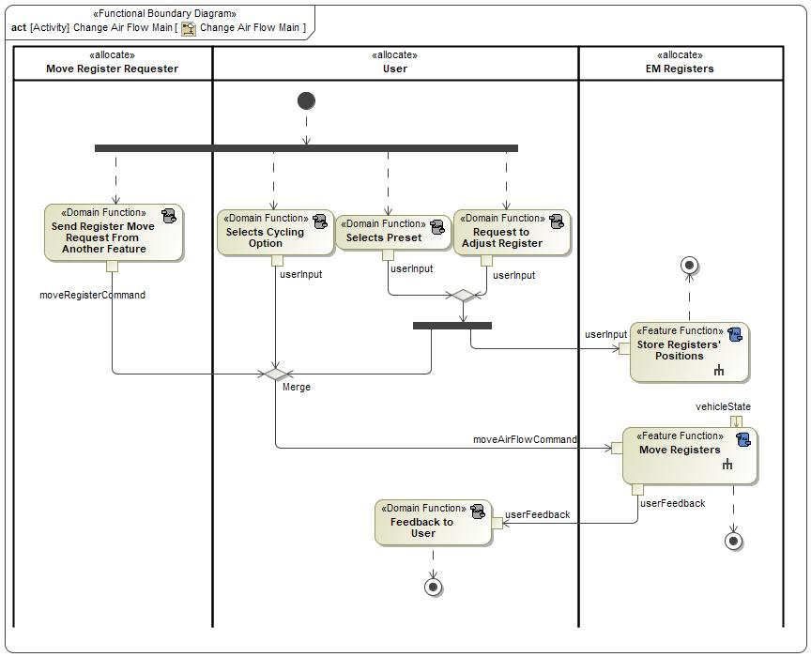

Figure 8: Change Air Flow Main

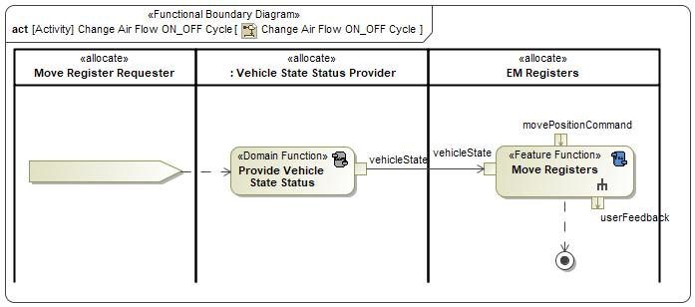

Figure 8: Change Air Flow ON_OFF Cycle

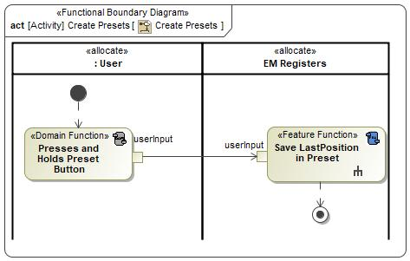

Figure 8: Create Presets

### List of Functions

**#Hint:** The functions shown in the Functional Architecture should be listed and described in the table below

| **Function Name** | Description | Comments |
| --- | --- | --- |
| *(activity)* Send Register Move Request From Another Feature | *(activity)* Function processes register move requests from another feature |  |
| *(activity)* Store Registers' Positions | *(activity)* Feature Function that stores register positions |  |
| *(activity)* Selects Cycling Option | *(activity)* Domain Function that allows user to select register cycling move option |  |
| *(activity)* Move Registers | *(activity)* Function to Move Registers to desired location |  |
| *(activity)* Selects Preset | *(activity)* Domain Function that allows user to select a preset register move command |  |
| *(activity)* Request to Adjust Register | *(activity)* Domain Function that initiates a user request to adjust a register position setting |  |
| *(activity)* Feedback to User | *(activity)* Provides Feedback to User via SYNC for EM Register Commands |  |

Table 17: List of Functions on Change Air Flow Main

| **Function Name** | Description | Comments |
| --- | --- | --- |
| *(activity)* Move Registers | *(activity)* Function to Move Registers to desired location |  |
| *(activity)* Provide Vehicle State Status | *(activity)* Function to provide vehicle status to the Move Registers function |  |

Table 17: List of Functions on Change Air Flow ON_OFF Cycle

| **Function Name** | Description | Comments |
| --- | --- | --- |
| *(activity)* Presses and Holds Preset Button | *(activity)* Function to store register position as a preset |  |
| *(activity)* Save LastPosition in Preset | *(activity)* Function Saves the last known register position |  |

Table 17: List of Functions on Create Presets

## Logical Architecture

**#Classification:** Functional Safety Analysis only

**#Hint:** FS Analysis requires a description of the boundary of the feature and its elements. A simple block diagram or a SysML Internal Block Diagram could be used to depict the Logical Architecture

***#Link:*** [*Ford Functional Safety Sharepoint*](https://pd3.spt.ford.com/sites/GlobalFunctionalSafety/Pages/default.aspx)

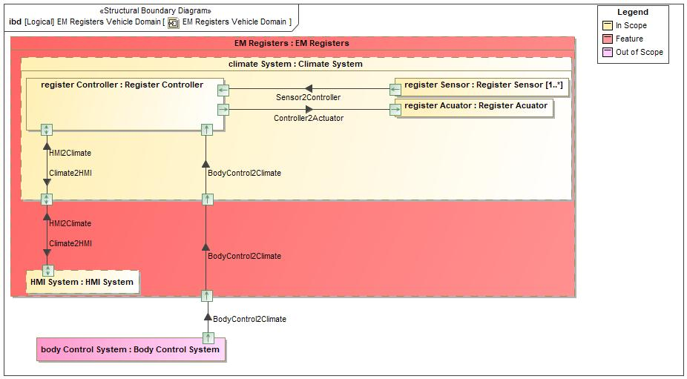

Figure 9: EM Registers Vehicle Domain

### Logical Elements

**#Hint:** Lists the elements of the Logical Architecture and the functions from the Functional Architecture, which are allocated to those elements.

|  |  |  |  |
| --- | --- | --- | --- |
| **Element Name** | **Description** | **Allocated Functions** | **Comments** |
| Body Control System | EM Registers gets VehicleStatus from the Body Control System |  |  |
| Climate System | Periodic Park Purge and Unlock Park Purge communicate with EM Registers through the Climate System. They are a part of the Climate system. |  |  |
| EM Registers | Feature block |  |  |
| HMI System | EM Registers communicates with Rejuvenate through the HMI System because Rejuvenate is part of the HMI system. HMI system stand in place of the User. |  |  |
| Register Acuator | Move the air vents to direct air in the desired direction. |  |  |
| Register Controller | Controller that controls the register actuators. |  |  |
| Register Sensor | Senses the position of the register actuator. |  |  |

Table 19: Logical Elements

### Logical Interfaces

**#Hint:** Describe the interactions of the feature with other features or elements.

|  |  |  |  |
| --- | --- | --- | --- |
| **Interface** | **Direction** | **Description** | **Value Range** |
| BodyControl2Climate | p1 (Body Control System) To p1 (EM Registers) | Provides vehicle status from Body Control System to Cimate System |  |
| p1 (EM Registers) To p2 (Climate System) | Provides vehicle status from Body Control System to Cimate System |  |
| p2 (Climate System) To p4 (Register Controller) | Provides vehicle status from Body Control System to Cimate System |  |
| Climate2HMI | p1 (Climate System) To p1 (HMI System) | Interface block that provides HMI with register positons |  |
| p5 (Register Controller) To p1 (Climate System) | Interface block that provides HMI with register positons |  |
| Controller2Actuator | p2 (Register Controller) To p1 (Register Acuator) | Provides Registers Positions Actuator Command signal from Climate Controller to Climate Actuator |  |
| HMI2Climate | p1 (Climate System) To p5 (Register Controller) | Provides Move Air FLow Commands from HMI to Climate System |  |
| p1 (HMI System) To p1 (Climate System) | Provides Move Air FLow Commands from HMI to Climate System |  |
| Sensor2Controller | p1 (Register Sensor) To p1 (Register Controller) | Provides Registers Positions Sensor Feedback from Climate Controller to Climate Sensor |  |

Table 18: Feature Interactions

# Open Concerns

**#Hint:** The following list presents open concerns, which have to be discussed or clarified over the course of the on-going requirements engineering.

| ID | Concern Description | e-Tracker / Reference | Responsible | Status | Solution |
| --- | --- | --- | --- | --- | --- |
| 1 |  |  |  |  |  |

Table 20: Open Concerns *(Not supported by MagicDraw report generation)*

# Revision History

**#Hint:** A new version number is assigned to a document with a given revision each time it is checked in to Team Center (TCSE). After release of a revision, the document cannot be edited and no new versions can be created on that revision. When updating the document after that, a new revision has to be created and new versions on that revision will be created upon checking in.

No Revision History found.

## Template Revisions

*#Important: Do not change this section*

|  |  |  |  |  |
| --- | --- | --- | --- | --- |
| Version | Rev. | Date | Description | Responsible |
| *0* | *6* | *2015-05-26* | * *Chapter “Feature Overview” and made a 2nd level heading.* * *Chapter “Feature Modeling” divided into 3 subchapter (“Scenarios”, “Use Cases”, “State Machines”) for different modeling methods* | *Jbaden1* |
| *0* | *7* | *2015-05-27* | * *Table of Content updated* * *Template Revision History chapter added* | *Jbaden1* |
| *0* | *8* | *2015-07-02* | * *Section “Unsettled Issues” added* | *Alevin7* |
| *0* | *9* | *2015-08-04* | * *Section “Feature Variants” added* * *Section “Feature Boundary Diagram” renamed to “Feature Context Diagram”* * *Document Properties adapted to match needs of VBA macros* | *Jbaden1, Awegman1* |
| *1* | *0* | *2015-09-11* | * *Section “Feature Variants” reworked* * *Feature Goals removed. Only “Safety Goals“ chapter remains.* * *Heading 2 formatting issues corrected.* * *Requirements / Use Cases Listing removed from traceability chapter.* * *Formatting of attribute table in Notation chapter corrected* * *Open Topics / Known Issues chapter moved to the end* | *Jbaden1* |
| *1* | *1* | *2015-11-16* | * *Table-Styles removed (for smooth VSEM import)* * *Some clean-up of sections “Purpose” and “Audience”* | *Awegman1, jbaden1* |
| *1* | *2* | *2016-02-26* | * *Minor corrections based on lessons learned from CC and PCL pilot (e.g. section market/regions) and discussion with Functional Safety Team (purpose of feature)* * *Footer corrected* * *Boundary diagram interface chapter renamed to influences.* | *Jbaden1* |
| *1* | *3* | *2016-02-26* | * *Minor corrections after review with Whitney Keith from Functional Safety team* | *Jbaden1* |
| *1* | *4* | *2016-03-10* | * *Some cleanup of meta-data in Word Properties* | *Jbaden1* |
| *1* | *5* | *2016-03-10* | * *Footer formatting corrected (Issue 19)* * *Results from review with Functional Safety Team incorporated (Issue 20).* | *jbaden1* |
| *1* | *6* | *2016-04-18* | * *Scenario Template added* | *Jbaden1* |
| *1* | *7* | *2016-04-18* | * *Chapter “Operation Modes and States” moved before “Use Case” section.* | *Jbaden1* |
| *1* | *8* | *2016-04-18* | * *Broken Wiki links repaired.* | *Jbaden1* |
| *2* | *0* | *2016-05-19* | * *Adapted to Specification_Macros.dotm V2.0* * *Requirements Templates chapter (ch. 1.7.1) no longer has an attribute table, but refers directly to the Wiki..* | *Jbaden1* |
| *2* | *1* | *2016-06-10* | * *Table for Context Diagram modified (lists external entities and Influence Description only)* | *Jbaden1* |
| *2* | *2* | *2016-07-08* | * *Template version added to footer* * *Several hints added to the various sections* * *Findings from Functional Safety Team incorporated.* * *RE_SafetyRequirement style added* | *Jbaden1* |
| *2* | *3* | *2016-09-21* | * *Update from Functional Safety Team incorporated (“Lessons Learned”, “System Behaviors for HARA”)* | *Jbaden1* |
| *2* | *4* | *2016-11-15* | * *Update from Functional Safety Team incorporated (“Lessons Learned”, “System Behaviors for HARA”)* * *Explanatory notes made more formal* | *Jbaden1* |
| *3* |  |  | *Skipped to synchronize with Specification_Macros.dotm* |  |
| *4* |  |
| *5* | *0* | *2017-01-13* | * *Meta data updated for specification macros, version 3.1* * *SW Unit chapter removed for the time being* * *Green boxes added for user hints* | *Jbaden1* |
| *5* | *1* | *2017-01-18* | * *Minor editorial changes* | *Jbaden1* |
| *6* | *0* | *2017-02-03* | * *CR48: Chapter 6 renamed from “Safety” to “Functional Safety”. New sub-chapter “Safety” introduced in Non-Functional Requirements section* | *Jbaden1* |
| *6* | *0* | *2017-04-28* | * *CR7: “RequirementsTraceability” chapter removed* | *Jbaden1* |
| *6* | *0* | *2017-11-15* | * *CR32/53: New Cover Sheet + Disclaimer replaces FAP-150 like ones.* * *CR75: Some rewording -> Terminology to Glossary, Notation -> Document Conventions* * *CR49: Rename “Assumptions & Constraints” to “Assumptions”* * *CR74: Safety Assumptions added to chapter 6.* * *CR58: Add function allocation column to Logical Architecture chapter* | *Jbaden1* |
| *6* | *0* | *2018-01-31* | * *CR63: Updated links to Functional Safety Sharepoint* | *Jbaden1* |
| *6* | *0* | *2018-07-24* | * *CR69: Add FSR to FeatureDoc* * *CR64: Add new section "Design Requirements" to Function Spec and Feature Spec* | *Jbaden1* |
| *6* | *0* | *2018-08-06* | * *CR53: some corrections for metada and formatting* | *Jbaden1* |
| *6* | *0* | *2018-09-28* | * *Broken links to RE Wiki repaired* | *Jbaden1* |
| *6* | *0* | *2018-10-31* | * *Cover sheet and footer more GIS like. Functional Safety team feedback incorporated:*   + *New subsections “Functional Safety Requirements, (Decomposed) FSRs and Parameters / Values*   + *Removal of “Logical Architecture”* | *Jbaden1* |
| *6* | *0* | *2018-12-12* | * *FSR template removed, now as a macro in the Specification_Macros.dotm* | *Jbaden1* |
| *N* |  | *2019-04-03* | * *Updated code for context diagrams, actors and use cases.* * *Updated code structure with all macros at the beginning.* * *Updated code to populate assumptions using element-assumption relationship or hazardous event.* | *snuesch* |
| *N* |  | *2019-04-18* | * *Added structural boundary diagram for FuSa based on TGB discussion.* * *Added operating modes to functional safety requirements.* | *snuesch* |
| *N* |  | *2019-04-25* | * *Improved export of actions and activities on functional boundary diagram.* | *snuesch* |
| *6* | *0b* | *2019-05-23* | * *Re-introduce “Logical Architecture” (for Functional Safety)* | *Jbaden1* |
| *N* |  | *2019-06-17* | * *Aligned “Architecture” section with RE template.* * *Made “Ford Documents” table more flexible.* * *Added template terms to glossary* | *snuesch* |
| *N* |  | *2019-06-25* | * *Improved use cases to handle Primary and Secondary actors.* * *Added Performance Requirements to Uncategorized.* | *snuesch* |
| *6* | *0b* | *2019-06-26* | * *Chapter “Logical Elements” in “Logical Architecture” section added (FuSa CR 15136240)* * *“References” and “Glossary” chapter moved from section “Feature Overview” to “Introduction”. References and Glossary should be available in the document as early as possible* | *Jbaden1* |
| *N* |  | *2019-07-25* | * *Added populated “Logical Elements” table and allocated functions.* * *Export documentation field of context diagram.* | *snuesch* |
| *N* |  | *2019-08-09* | * *Export documentation field of use case diagram.* * *Fixed bug in Feature Requirement Verification Method.* * *Simplified export of References without publisher.* | *snuesch* |
| *N* |  | *2019-08-21* | * *Improved glossary and acronym tables* | *snuesch* |
| *N* |  | *2019-08-28* | * *Fixed bug in populating title in header* | *snuesch* |
| *N* |  | *2019-09-16* | * *Updated bibliography export* | *snuesch* |
| *N* |  | *2019-09-27* | * *Updated export of Verification Method and Requirement Status for Feature Requirements and V&V Method for Functional Safety Requirements.* | *snuesch* |
| *O* |  | *2019-11-12* | * *Updated bibliography export to include URL.* * *Allow hardware element on context diagram.* * *labelTag variable can be used to filter revision history.* * *Added logical property element type to beplled in from structural boundary diagram.* | *snuesch* |

# Appendix

## Definitions

| **Definition** | **Description** |
| --- | --- |
| calibrate | A process that will provide future accurate positioning for the registers. The process entails moving the registers to the end points and recording the feedback from the sensors. This feedback is used to recalibrate the future voltage commands to move the registers. |
| HOME | Value that denotes the Home position the registers will move to when the car is turned off. |
| LastPosition | Denotes the last stationary position that the registers were in. For example the position before the vehicle was turned OFF, before a Cycling option was selected, or before another feature requested to move the registers. |
| status of EM registers |  |

Table 21: Definitions used in this document

## Abbreviations

No acronyms specified.

Document ends here.